**Green house monitoring and control System**

**Introduction:**

Greenhouse Monitoring and Control System is the technical approach in which the farmers in the rural areas will be benefitted by automatic monitoring and control of greenhouse environment. It replaces the direct supervision of the human. It focuses on the factors like temperature, soil moisture and humidity. Greenhouse is a building where plants are grown in a controlled manner. Nowadays due to urbanization and lack of land availability there is a great need to construct the Greenhouses which will be reserved mainly for growing crops. With the advancement of technology we can control and monitor the multiple Greenhouses using IOT through Arduino mobile applications.

**Overview:**

This project describes the design of a greenhouse monitoring & controlling system based on IOT using Arduino. In this we use sensors to measure temperature, soil moisture and humidity. The gathered information sends to the mobile. We have used the tools like IBM cloud, node red, IOT platform and cloudand db. The values are displayed in mobile which was designed through software building with two switches called sprinkler on and off to control the conditions of greenhouse.

**Purpose:**

Monitoring and controlling the green house parameters like temperature, humidity, and soil moisture. The other factors which are essential for the growth of plants are also monitored and controlled by this system.

**Literature Survey:**

**Existing problem:**

Lack of land availability and drastic changes in climate there is a great need to construct the Greenhouses which will be reserved mainly for growing crops.

**Proposed solution:**

Advancement of technology we can control and monitor the multiple Greenhouses using IOT through Arduino via mobile controlling. This is through sensors that detects the requirements of crops and exhibits on mobile in which it can control sprinkling action.

**Theoretical analysis:**

**Block diagram:**

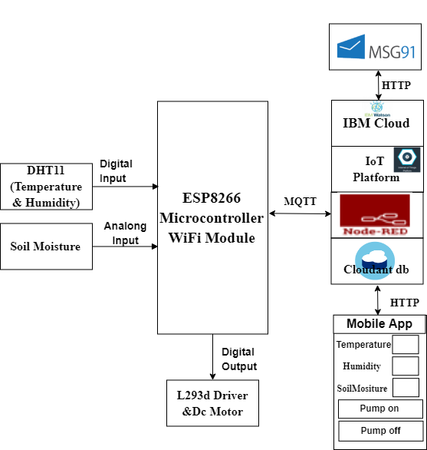

**Software designing:**

In this we used node red to design the structure and generated a python code. We used IBM IOT to connect the three sensors and codded to generate the output to mobile. We have used sprinkler on and sprinkler off which can be operated through mobile. This helps to control the temperature, humidity and soil moisture. We also get message to our mobile.

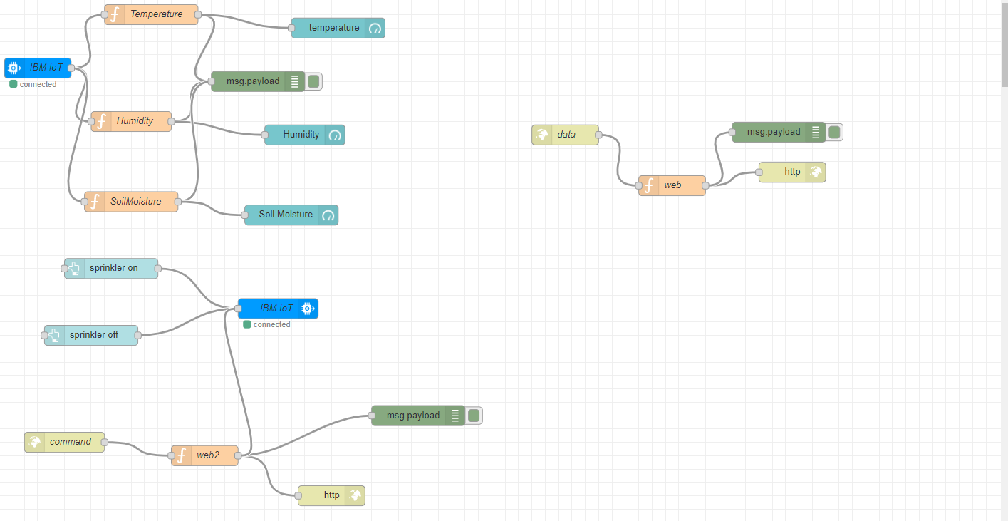

**Experimental investigations:**

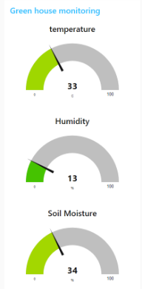

**Flow chart:**

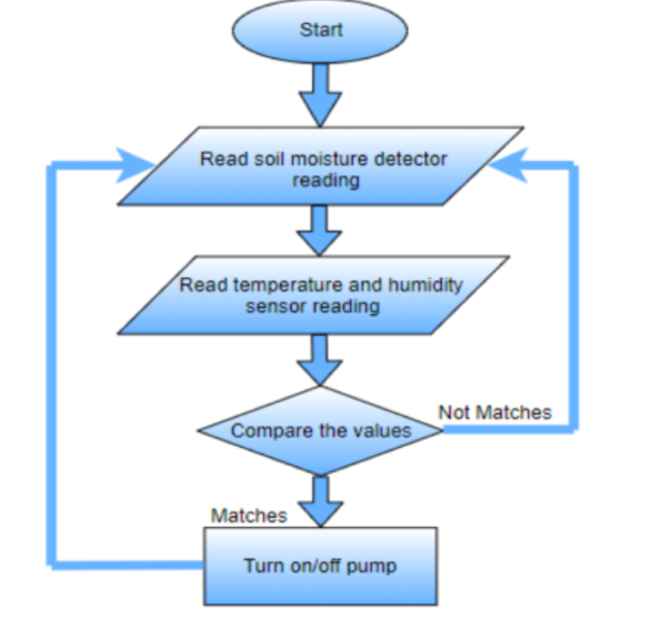

**Result:**

